Every one running a lending business, getting back the money is always the priority. Since the world is a global village with everything at the control of our mobile phones, financial institutions have taken their products to the digital space. Since a lot of lending is done online, getting paid back is very critical.

**Irorun and Opticom**

*Irorun* is a loan financing app that provides loans to borrowers via their mobile phones. Irorun allows borrowers to access quick and easy loans directly from their mobile phones without having to visit a bank in person.

Opticom : Is a company that provides financial management services and solutions to businesses and individuals. They specialize in debt collection, credit management and other financial services.

|  |  |
| --- | --- |
| **IRORUN** | **OPTICOM FINANCE** |
| **Products**:  irorun offers three(3) types of products.   * Easy credit * Easy credit supreme * Easy credit free | * Opticom Easy loan * Opticom DigiLoan * Opticom salary loan   They also offer services like car leasing, solar finance, back to school loans, investment management |
| **Interest rates:**  *Easy credits:* It has a 15% interest rate on every N (5,000-10,000) repayable within 15 days.  *Easy credit supreme:* interest rate of 10%on every N(5,000-50,000)  *Easy credit free:* this is for exclusive customers with good creditworthiness. It has zero(0)% rate on every N5,000 borrowed. | *Opticom easy loan:* with a maximum of N10,000 at an interest rate of 5%  *Opticom DigiLoan:* maximum of N100,000 with an interest rate of 10%  *Opticom salary loan*: similar to that of DigiLoan, maximum of N100,000 and an interest rate of 10% |
| **Fees:**  All of irorun loans have the same processing fees and also have the same flat rate of N1,000 on every principal amount borrowed. | Their processing fees varies depending on the type of loan you’re applying for. |
| **Tenor:**  Easy credit: The loan is to be paid back within 7-15 days  Easy credit supreme: Repayable within 7-30days  Easy credit free: Repayable within 7 days | Opticom easy loan: it is repayable within 1-2 weeks  Opticom DigiLoan: Repayable within 1-3 months  Opticom salary loan: Repayable within 1-3 months |
| **Savings**  Irorun finance does not allow users or borrowers save money in their wallet baca use they are registered as a lending platform and not a financial institution. | Opticom finance allows users and borrowers to be able to save money in their wallet account and have various saving plans for interested customers and the rates are really juicy. |

**IRORUN AND OPTICOM (Overview and summary)**

Irorun finance is a subsidiary of Lendsqr, it is a fin tech company that provides lending and credit services to individuals and businesses. Irorun specializes in providing loans to small and medium sized enterprises (SMEs) in Nigeria. Due to its flexible nature, individuals and business can access loan online via their mobile phone thereby making loans accessible without stress or worry.

Irorun uses an advanced algorithm and machine learning to analyze borrowers creditworthiness and determine their loan eligibility. Their loan amount and repayment is flexible and customized to meet individual needs of each borrower. Once the loan is approved, the funds are disbursed directly into the borrowers bank account within a short time frame.

Opticom finance is a company that provides financial management services and solutions to businesses and individuals. They specialize in debt collection, credit management and other financial services. They pride themselves in customers transparency, customers-centricity professionalism and innovation. Opticom can be categorized as a fin tech company due to the type of services they provide.

**Irorun vs. opticom: General comparison**

To be-honest, it is obvious that opticom finance is a more bigger finance provider than irorun. Nevertheless, both finance providers have their uniqueness to themselves. Starting with ownership, both are owned by Nigerians who have been in the financial industry for quite a while now. They both strive to achieve the same goal with is to provide finance to those in urgent need of funds at very affordable rates.Both companies have come up with an app that allows borrowers to access loans easier and by signing up on the app and adding their personal informations like their( BVN) bank verification number, a valid government issued identification and account details and signing up is free! Yeah free with no application or sign-up fee

**Irorun vs. opticom: products**

Opticom finance definitely have more products to offer than irorun. Optimum services/ products ranges from finance and leasing to Loans and lending to investment management and also credit management.

Irorun also has great services / products they offer, but is limited to being only a lending finance provider. They have great loan offers, good work ethics, nice and cheap processing fees, affordable interest rates. They also have rewards or packages for their loyal and esteemed customers for example they reach out customers on their birthday and give gifts to the loyal ones, they also give free or no interest loan to loyal customers. Isn’t that amazing! What lending finance provider does that?? Only irorun!

**Irorun vs. Opticom: fees**

Irorun collects a sum of N400 AD processing fee for any type of loan one might be requesting for on the app or the website. For all its loan type, they have the same processing fees. No discrimination amongst the fee one is to pay for whatever type of loan.

Opticom finance displayed no processing fee on their website and even on their app, my guess is that there is no processing fee because it accepts collateral from each borrower as a form of security for the loan.

Conclusively, both finance providers have their strengths and weaknesses but it would be better for both to harness more of their strength and also focus on how to combat their weaknesses.

**Irorun vs.Opticom: Strength**

**Irorun**

* Use of advanced algorithms and machine learning to analyze its customers
* Easy access to loans
* Customized loans
* Fast processing time
* Good ethical behavior/standards

**Opticom**

* Comprehensive financial services
* More experienced team
* Customized services

**Weaknesses**

**Irorun**

* Limited financial services
* Very high interest rates+ flat rates
* High late payment penalties
* Saving money is not allowed
* Lack of user friendly application

**Opticom**

* Limited loan options
* Lack of transparency about the services they offer
* Limited to only those with collateral

Ways irorun can improve

* Build a more user friendly application
* Build a wider reach or target audience
* Offer competitive rates
* Re-evaluate how interest is calculated in outstanding balances
* Provide excellent customer service
* Allow for savings in the wallet
* 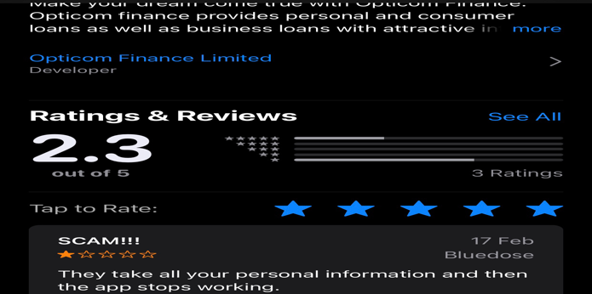Adapt to changing market trends

